## Raptor Effects Monitoring

The Baffinland FEIS states that a monitoring program for raptors will be used to assess the accuracy of predictions by comparing measurable parameters from within the footprint to those documented at appropriate reference sites (Baffinland Iron Mines Corporation 2012). NIRB Project Condition #74 identifies Peregrine Falcon and Gyrfalcon (*Falco rusticolus*) as key indicators for follow up monitoring of birds (Nunavut Impact Review Board 2014). Further, during the final hearing, Baffinland committed to monitoring relevant sections of the project area for Peregrine Falcon nesting activities (Commitment #75).

### Background 2011–2019

Arctic Raptors Inc. (ARInc.) personnel have conducted raptor monitoring as part of the Baffinland Iron Mine terrestrial baseline surveys and terrestrial effects monitoring efforts from 2011 through 2020. In general, surveys of known nesting sites have been conducted by truck along the Tote Road and helicopter from the Mine Site to Milne Inlet. Over this period, monitoring objectives have been modified periodically to align with priorities for each phase of the Project (e.g., pre-baseline, construction and operations of the Early Revenue Phase).

In 2011 surveys were conducted based on nesting site locations provided by Baffinland to substantiate and undertake quality control of monitoring data that had been collected from 2006 to 2008 in the RSA (extending from Milne Inlet in the north to Steensby Inlet in the south). A second goal was to gauge the potential for establishing a dedicated study area to be based at Steensby Inlet that could serve as a replicate for the long-term monitoring program located near Rankin Inlet, Nunavut. ARInc. initiated a banding program of breeding adults and nestlings, collected blood samples, searched for nesting locations that had not been previously identified, and conducted small mammal trapping following protocols already in place at Rankin Inlet. Surveys were conducted in 2012 of all known nesting sites with the same goals that had been identified in 2011. Surveys conducted in 2013 investigated nesting habitat selection of Peregrine Falcons (PEFA) and Rough-legged Hawks (RLHA). Fieldwork in 2014 involved ongoing extensive surveys (occupancy and productivity) of known nesting sites within the RSA and additional coverage of areas not previously surveyed to validate habitat selection models.

Prior to the 2015 breeding season, ARInc. was tasked with providing a monitoring program to estimate potential effects of the Project. This marked a departure from extensive monitoring of known nesting sites throughout the RSA to monitoring nests within a 10 km buffer of the PDA, hereafter referred to as the Raptor Monitoring Area (RMA). The density of nesting sites was distributed disproportionately, with higher densities located within 3 km of anthropogenic disturbance and much lower density beyond 3 km of disturbance. Thus, starting in 2015, survey effort shifted from extensive monitoring of known nesting sites throughout the RSA to monitoring of nesting sites only within the RMA as well as searching for previously unknown nesting sites. In 2015, efforts to locate previously unknown nest sites focused on those areas further from disturbance to address the limitation associated with small sample size further from disturbance. Survey effort in 2016 similarly focused on monitoring of known nesting sites within the RMA, as well as searching for previously unknown nesting sites, but also placed greater effort on multiple visits to address detection error. Fieldwork, analysis and reporting in 2020 followed the methodology adopted in 2016; additional effort was placed on addressing issues raised in previous reports regarding terminology, methodology to address the effect of alternative nesting sites on estimates of occupancy and reproductive success, and collection of additional data to address the influence of prey and weather on these same indicators.

### Terminology

The terminology used throughout this report follows Franke et al. (2017). The following terms are highlighted to clarify terminology used in this report, and/or to distinguish key terms used from similar terms that have distinct meaning:

**nest** —The structure made or the place used by birds for laying their eggs and sheltering their young (Steenhof and Newton 2007)regardless of whether eggs are laid in the nest in a given year or in any year (Millsap et al. 2015, Steenhof et al. 2017); see Scrape for Gyrfalcons.

**nesting site** — The substrate that supports the nest or the specific location of the nest on the landscape (Ritchie and Curatolo 1982, Millsap et al. 2015, Steenhof et al. 2017).

**alternative nesting site** — One of potentially several nests within a nesting territory that is not a used nest in the current year (Millsap et al. 2015).

**fully surveyed site** — A nesting site that receives two or more visits in a single season, where each visit is associated with a different phase in the breeding cycle (pre-laying, incubation, brood rearing), or within phases but visits are separated by sufficient time to be independent observations (e.g., early incubation and late incubation).

**nesting territory** — An area that contains, or historically contained, one or more nests within the home range of a mated pair; a confined locality where nests are found, usually in successive years, and where no more than one pair is known to have bred at one time (Newton and Marquiss 1984, Steenhoff and Newton 2007). Note that a nesting territory may or may not be defended (Postupalsky 1974), and probably does not include all of a pair’s foraging habitat (Newton and Marquiss 1984, Steenhoff and Newton 2007).

**occupancy** — The quotient of the count of occupied nesting territories and the count of known nesting territories that were fully surveyed in each breeding season (Franke et al. 2017).

**brood size** — The actual number of young hatched from a single nesting attempt by a pair of birds. For studies in which mortality that occurs between hatching and the first observation of the brood is unknown, it is appropriate to report brood size (i.e., number hatched) only for broods equal to, or less than 10 days of age. For broods older than 10 days of age, see Brood Size ≥10 days. Report mean and standard error, or standard deviation.

**brood size ≥ 10 days** — The number of young hatched from a single nesting attempt by a pair of birds. For studies in which mortality that occurs between hatching and the first observation of the brood is unknown, and nestlings are equal to, or greater than 10 days of age, but less than Minimum Acceptable Age MAA) for assessing success. Report mean and standard error, or standard deviation.

**minimum acceptable age (MAA)** for assessing success — A standard nestling age at which a nest can be considered successful. An age when young are well grown but not old enough to fly and after which mortality is minimal until actual fledging. Typically 80% of the age that young of a species normally leave the nest of their own volition for many species, but lower (65–75%) for species in which age at fledging varies considerably or for species that are more likely to leave the nest prematurely when checked (Steenhoff and Newton 2007).

**daily survival rate (DSR)** — The probability that at least one young or egg in a nest will survive a single day (Dinsmore et al. 2002, Steenhoff and Newton 2007).

**nest survival** — The probability that a nesting attempt survives over the complete nesting period. When DSR (Dinsmore et al. 2002) is assumed to be constant over time and E is the nesting period (usually expressed in days), nest survival is DSR^E; otherwise nest survival is the product of each estimated DSR. For raptors, nest survival is the equivalent of nesting success for egg-laying pairs (Steenhof et al. 2017).

**productivity** — The number of young that reach the minimum acceptable age for assessing success; usually reported as the number of young produced per territorial pair or per occupied territory in a particular year (Steenhoff and Newton 2007, Steenhof et al. 2017).

**total production** — The total number of young detected.

### Breeding Phenology

Breeding phenology is an important determinant of the timing of occupancy and productivity surveys. In Nunavut, the earliest documented arrival for Peregrine Falcons is May 10 at a known breeding site near Rankin Inlet. Although timing of arrival on territory varies with spring conditions, most sites are occupied during the third week of May. Median laying date in Rankin Inlet (June 9 ± 4.0 days) was earlier than Igloolik (June 15 ± 3.6 days; Chi² = 31.56, p <0.001) and north Baffin Island (June 16 ± 3.5 days; Chi² = 35.56, p <0.001) with no difference observed between Igloolik and north Baffin Island (Chi² = 0.77, p = 0.38) (Jaffré et al. 2015). The incubation period of the fourth laid egg (33 days) is similar to what has been reported elsewhere (Burnham 1983). Rough-legged Hawk breeding phenology is very similar to Peregrine Falcons but is typically advanced by a week to 10 days (Poole and Bromley 1988). Additionally, the presence of breeding pairs in locations where ground squirrels are absent (as is the case on Baffin Island) is typically cyclic in association with lemming abundance. The timing of surveys on Baffin Island was conducted to match the phenology of local breeding birds.

### Raptor Monitoring Data

The landscape is generally rugged, and elevation varies ranging from sea-level to 685 meters above sea-level. The area includes a wide valley associated with Philip’s Creek surrounded by high plateaus and mountains. The valley extends southward into poorly drained plains and rolling tundra. Vegetation is patchy, and dominated by mountain avens (*Dryas* spp.) and Arctic willow (*Salix arctica*), along with alpine foxtail (*Alopecurus* spp.), wood rush (*Luzula* spp.), and saxifrage (*Saxifraga* spp). Dry or high elevation sites are very sparsely vegetated, whereas wet areas have a continuous cover of sedge (*Carex* spp.), cottongrass (*Eriophorum* spp.), saxifrage, and moss. Peregrine Falcon and Rough-legged Hawk are the most common raptor species. Gyrfalcon, Snowy Owl, and Common Raven were also encountered. The spatial extent of the 2019 surveys was limited to nesting sites within the RMA (Map 8).

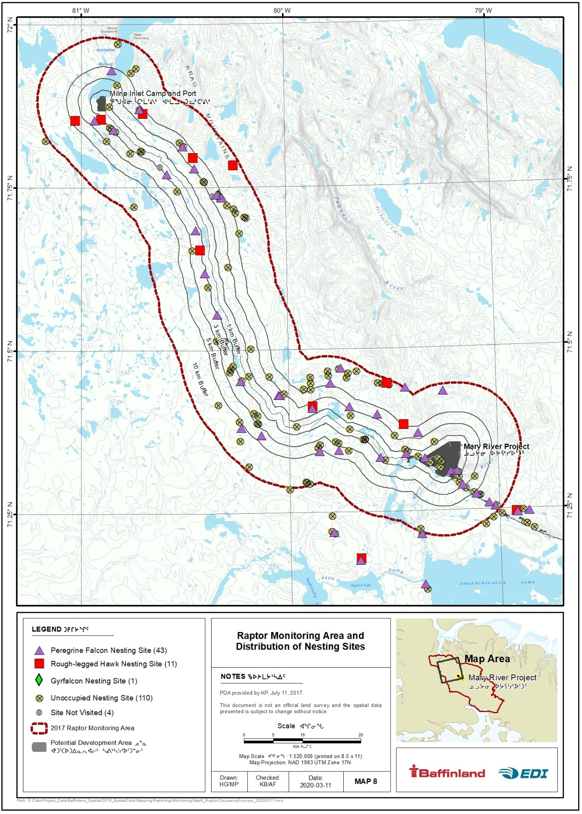

Map 8 Raptor monitoring area and distribution of nesting sites during the 2019 occupancy and productivity surveys; Mary River Project.

### Methods

Raptor surveys from 2011 to 2014 were conducted throughout the region extending from Milne Inlet to Steensby Inlet, and results of those surveys were reported in previous annual monitoring reports (EDI Environmental Dynamics Inc. 2013, 2014, 2015, 2016). Survey efforts from 2015 to 2020 focused on monitoring of occupancy and reproductive success only within the RMA, and opportunistically documented previously unknown nesting sites.

#### Helicopter Survey

Three helicopter-based surveys were conducted in 2020: June 25 to 28 (XX hours), July 18 to 21 (XX hours), August 11 to 14 (XX hours). The focus of these surveys was to search known nesting sites for the presence of cliff-nesting birds. In addition to the structured surveys, favorable habitat was searched opportunistically when ferrying between known sites, camps or other mine infrastructure, and when raptors or signs of site use (e.g., whitewash, orange-colored lichen, and unused nests) were observed. Sites were considered occupied if one or more adults displayed territorial or reproductive behavior (e.g., vocalization and/or flight behavior associated with defense of breeding territory or presence of nest building, nest, or eggs). Locations with partially built or unused nests without detection of breeding aged adults were noted as such (i.e., no birds detected).

#### Distance to Disturbance

Within the spatial extent of the study area, ESRI ArcGIS for Desktop v.10.3 (ESRI 2011) was used to calculate the distance from all raptor nest sites to the nearest mapped disturbance features (e.g., Project infrastructure). Shapefiles were derived from CAD drawings provided by HATCH, the on-site procurement and engineering contractors. From the CAD files, the Mine Site, Milne Port and Tote Road footprints were used to represent current and proposed disturbance as of September 2014. The ArcGIS Near Tool was used to calculate the Euclidean distance for each nest site (i.e., point location) to the nearest point of the Project footprint. Sites that were located within the spatial extent of the PDA received a distance value of 0 meters. Distance to disturbance (DD) values for only those sites within the RMA were retained for effects analysis on occupancy and reproductive success.

#### Distance to Nearest Neighbour

Nearest neighbour distances (NNDs) were calculated in R (R Development Core Team 2019) using the ‘sp’', ‘rgeos’’, and ‘geosphere’ packages. These packages were used to transform the geographic coordinates describing nesting site locations into spatial objects, calculate pairwise distances and identify the shortest distance between all known nest site locations, and the nearest occupied territory (DNON, i.e., distance to nearest neighbour).

#### Assigning Nesting Sites to Nesting Territories

In the absence of marked individuals, it can be challenging to definitively identify alternative nesting sites. Failure to account for alternative nesting sites can lead to underestimating demographic parameters such as annual productivity. To address this problem, a rule-based approach was used to estimate the number of alternative nesting sites within the RMA. Mean NND within the RMA equalled 1.2 km, and this information was used with the following rule set to identify clusters of nesting sites that were potential alternative nesting sites (Figure 6‑1):

* If two species-specific nesting sites were within 1 km of each other, they were considered alternative nesting sites in a single nesting territory.
* If two nesting sites within 1 km of each other were occupied by the same species in a given year, they were considered separate territories.
* If multiple species-specific nesting sites were within 1 km of one another, discrete geographic landforms or discontinuities in cliff structure were used to separate or combine sites into territories.

Temporal patterns of multi-species occupancy were used to assess the plausibility of decisions based on the application of the three rules listed above. For example, if two nesting sites were located within 1 km of each other and were occupied by two different species in alternating years, these nesting sites were identified as distinct alternative nesting sites for each species.

Assigning Identification Numbers (ID) to Nesting Territories was conducted according to the following rule set:

* Nesting Territory IDs were assigned within species only (e.g., Nesting Territory IDs for PEFA and RLHA were never shared).
* Nesting Territory IDs were assigned using the Identification Number of one of the Nesting Sites in the cluster according to the following rule set, in order of priority:
  + 1. length of tenure (i.e., nesting sites with the longest tenure); and
    2. first tenure (i.e., nesting sites with the first tenure in the event length of tenure was equal).

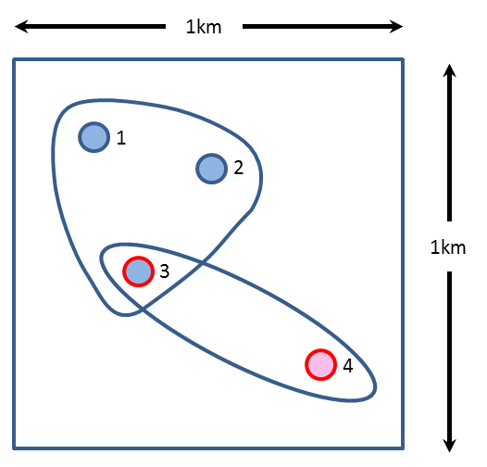

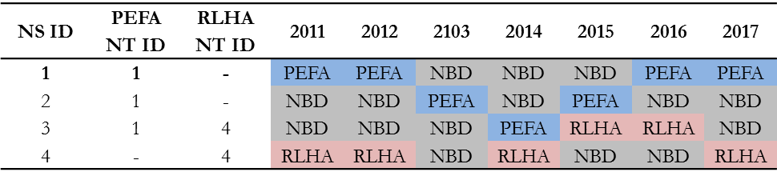

Figure 6‑1 Rule-based approach used to assign nesting sites to nesting territories for occupancy modelling.

A cluster of four nesting sites within 1 km of one another that exhibit a site occupancy history among seven years for two species (PEFA and RLHA). Nesting Sites 1 and 2 (blue circles with blue borders) have been occupied solely by PEFA. Nesting Site 4 (red circle with red border) has been occupied solely by RLHA. Nesting Site 3 (blue circle with red border) has been occupied by both PEFA and RLHA. In this example, Nesting Sites 1, 2 and 3 are grouped into a single PEFA Nesting Territory and assigned Nesting Territory ID 1 based on PEFA–specific tenure length (Nesting Site 1 has the longest tenure) and first tenure. Nesting Sites 3 and 4 are grouped into a single RLHA Territory and assigned Nesting Territory ID 4 based on RLHA–specific tenure length (Nesting Site 4 has the longest tenure) and first tenure. Unique nesting locations are ultimately defined by a Nesting Territory ID and a Nesting Site ID (E.g., NT ID 1, NS ID 2). NBD = no birds detected.

#### Occupancy Modelling

Although estimation of nesting site occupancy can serve as a metric of population status (MacKenzie et al. 2002, 2003), detection of nesting pairs is invariably imperfect, and estimating the proportion of occupied sites without accounting for detection error can lead to underestimation of true occupancy (Kéry and Schmidt 2008). Hierarchical occupancy modeling can estimate parameters that influence occupancy and simultaneously account for a detection probability less than 1 (Marsh and Trenham 2008).

Occupancy is limited to one of only two outcomes (occupied or not occupied) and is therefore a Bernoulli trial. The modelling process estimates colonization (i.e., an unoccupied site becomes occupied), extinction (i.e., an occupied site becomes unoccupied), and survival (i.e., an occupied site remains occupied), and covariates can be added to the model to test whether they influence the parameters by linking specific covariates to each of the three parameters using a logit link function.

Multi-year occupancy was calculated in R (R Development Core Team 2019) using the ‘unmarked’package. When appropriate, data were standardized (e.g., the covariate distance to nearest occupied neighbour was standardized by subtracting the mean from each distance value and dividing by the standard deviation) and then formatted specifically for ‘unmarked’using the *unmarkedMultFrame* function. Occupancy dynamics among years were investigated separately for Peregrine Falcons and Rough-legged Hawks. To do so, the total number of nesting sites were filtered to include only sites that were occupied at least once between 2012 and 2020 for each species. A total number of XX and XX nesting sites were used to analyze Peregrine Falcon and Rough-legged Hawk occupancy dynamics, respectively. Model fitting of candidate models was performed using the *colext* function. Akaike Information Criterion (AIC) was used for model selection. Thirteen candidate models were selected *apriori* to address anthropogenic (i.e., distance to disturbance) and ecological factors (i.e., distance to nearest occupied neighbour), and interactions among factors with potential to influence model parameters (initial colonization, annual colonization, annual extinction, and detection probabilities). For example, the effect of distance to disturbance may vary with distance to nearest neighbour (i.e., the effect of distance to disturbance may depend on proximity of neighbouring nesting sites). The aim of this analysis was two-fold: 1) to estimate the proportion of occupied nesting sites annually, and identify factors that may influence whether sites were occupied, and; 2) to estimate the overall trend in nesting site occupancy from 2012 to 2020 (2011 was dropped from the analysis as only four nesting sites were fully surveyed in 2011). Trend was estimated using annual occupancy probabilities to calculate average rate of change (λ) at the population level (MacKenzie et al. 2003) where a mean value <1 indicates population decline and >1 indicates an increase.

#### Reproductive Success

Given that nestling age during the survey period varied annually among years and sites, measures of annual productivity *per se* are expected to be biased high (i.e., counts of nestlings are often done when nestlings are less than the MAA). For this report, any nesting site that was surveyed at least twice was considered “fully surveyed”, and estimates of reproductive success were reported as the number of young hatched from a single nesting attempt by a pair of birds (i.e., mean brood size ≥ 10 days ± standard deviation) for fully surveyed sites. All nesting sites were contained within a unique nesting territory (i.e., no nesting territories were occupied by more than one pair of birds, regardless of the existence of known alternative nesting sites within nesting territories).

To investigate patterns in nesting site survival (i.e., the probability that a nesting site produced young given that the nesting site was occupied) across space and time, we compared three models that estimated spatiotemporal variation among nesting sites, as follows: 1) spatial structure remained static across all years; 2) spatial structure varied annually, and; 3) an autoregressive spatial structure, where the spatial effect in a given year depended upon the previous year. All models were constructed and executed within the framework of Integrated Nested Laplace Approximation (INLA) using the R package ‘R-INLA’ (Rue et al. 2014), and compared using deviance information criterion. Covariates contained within the top model were individually assessed based on the proximity of their posterior distributions to zero.

#### Small Mammal Monitoring

Two small mammal trapping sessions were conducted from June 16 to 22 and August 7 to 14, 2019, following the procedure outlined by Cadieux et al. (2015). Two trapping sites were selected based on habitat thought to be suitable for both brown and collared lemmings (presence of old lemming nests, runways and burrows, seed-bearing plants, wet and dry tundra, and a total area that is equal to or larger than 700 m in length). In addition, areas accessible by a light vehicle along the Tote Road were selected.

Two permanent line transects were staked (GPS-located) at each trapping site. Line transects were 300 m long with 20 stations spaced 15 m apart. Each station consisted of a flagged stake and three museum special snap traps attached to the stake using string (1 m in length), for a total of 240 traps. Traps were evenly distributed around the stake at a distance no further than 1 m and baited with peanut butter.

Traps were checked once daily for three trap-nights, resulting in 720 trap-nights per trapping session. Recorded information included captures, misfires, or missing bait from each trap.

#### Avian Prey Monitoring

### Results

#### Nesting Site Detections

A total of 169 unique nesting sites have been detected in the RMA from 2012 to 2019. Among years, the greatest number of previously unknown nesting sites detected occurred in 2014 (N=19) and 2015 (N=32) due to efforts associated with the model validation aspect of the nesting habitat selection study (Galipeau et al. 2019) and efforts to increase sample sizes in regions further from a disturbance in 2014 and 2015, respectively. The number of known nesting sites has increased considerably in the RMA since 2012 (from N=107 to N=169); the percentage of known sites checked annually has remained high (range of 83% to 100%).

In 2019, 165 nesting sites were surveyed at least three times throughout the breeding season. For all years pooled, cliff-nesting raptors were detected at approximately half of known nesting sites that were checked. However, in years when detection of Rough-legged Hawks was low (i.e., 2013 and 2017 ̶ 2019), cliff-nesting raptors were detected at approximately one third of known nesting sites. Of the 165 nesting sites visited in 2019, cliff-nesting raptors were detected at 55 sites; 43 held Peregrine Falcons, 11 held Rough-legged Hawks, and one held Gyrfalcons. Raptors were not detected at 110 known nesting sites (Table 6‑2).

| Table 6‑2 Summary statistics for survey effort and detections at known Peregrine Falcon and Rough-legged Hawk nesting sites within the RMA from 2012 to 2019. | | | | | | | | | | | | |  |
| --- | --- | --- | --- | --- | --- | --- | --- | --- | --- | --- | --- | --- | --- |
| Variable | | **Year** | | | | | | | | | | |  |
| **2012** | | **2013** | | **2014** | | **2015** | **2016** | **2017** | **2018** | **2019** | **2020** |
| Total nesting sites known annually | 107 | | 108 | | 127 | | 159 | | 162 | 167 | 169 | 169 | 175 |
| New sites found annually | — | | 1 | | 19 | | 32 | | 3 | 5 | 2 | 0 | 6 |
| Count of sites checked | 107 | | 90 | | 125 | | 147 | | 142 | 166 | 166 | 165 | 175 |
| Count of checked sites occupied | 76 | | 30 | | 77 | | 99 | | 70 | 63 | 63 | 55 | 89 |
| Count of fully surveyed sites | 50 | | 35 | | 90 | | 113 | | 99 | 158 | 164 | 164 | 175 |
| Count of sites no raptors detected | 31 | | 60 | | 48 | | 48 | | 72 | 103 | 103 | 110 | 86 |
| Proportion of sites no raptors detected | 29% | | 67% | | 38% | | 33% | | 51% | 62% | 62% | 67% | 49% |
| Count of sites PEFA detected | 29 | | 29 | | 43 | | 50 | | 48 | 50 | 49 | 43 | 42 |
| Proportion of sites PEFA detected | 27% | | 32% | | 34% | | 34% | | 34% | 30% | 30% | 26% | 24% |
| Count of sites RLHA detected | 45 | | 1 | | 31 | | 47 | | 18 | 5 | 12 | 11 | 47 |
| Proportion of sites RLHA detected | 42% | | 1% | | 25% | | 32% | | 13% | 3% | 7% | 7% | 27% |

#### Assigning Nesting Sites to Nesting Territories

Only nesting sites occupied at least once by Peregrine Falcons or Rough-legged Hawks since 2012 were used to delineate nesting territories (n.b., the analysis conducted for the 2018 report incorporated known nesting sites prior to 2012, including those that had not been occupied from 2012 to 2018, and those that had been occupied by irruptive species such as the Snowy Owl). As indicated, the 2019 report only uses sites occupied by Peregrine Falcons and Rough-legged Hawks from 2012 to 2019. This resulted in 94 nesting sites for Peregrine Falcons, and 91 nesting sites for Rough-legged Hawks. Using the methods outlined in Section 6.3.5.4 – Assigning Nesting Sites to Nesting Territories, the 94 peregrine nesting sites were reduced to a total of 76 distinct nesting territories, and the 91 Rough-legged Hawk nesting sites were reduced to 71 distinct nesting territories (Figure 6‑2).

#### Occupancy

From 2012 to 2019, the top model for the Peregrine Falcons indicated that colonization and extinction were best explained by yearly variation (see Table 6‑3). Distance to disturbance, and distance to the nearest neighbour appeared in the third and fifth models with AIC of 7.13 and 8.71 respectively; a drastic change from the top model and an indication that neither of the covariates explain colonization and extinction better than natural variation from year to year. The time-series (Figure 6‑3) indicates relative stability among years as indicated by $λ=1.01±0.17$. With highly varied occupancy across years, the best model for Rough-legged Hawks included a year effect for colonization and extinction (Table 6‑4). Multi-year occupancy for Rough-legged Hawks (Figure 6‑4) indicated $λ=3.11±6.08$ from 2012 to 2019. Considerable annual variation exists with lows in 2013 and 2017. As is typical among specialists like Rough-legged Hawks, occupancy can vary widely across years when main prey species (i.e., microtine rodents) are not available. When yearly occupancy is summarized among years (Figure 6‑4), two peaks are clearly evident in 2012 and 2015.

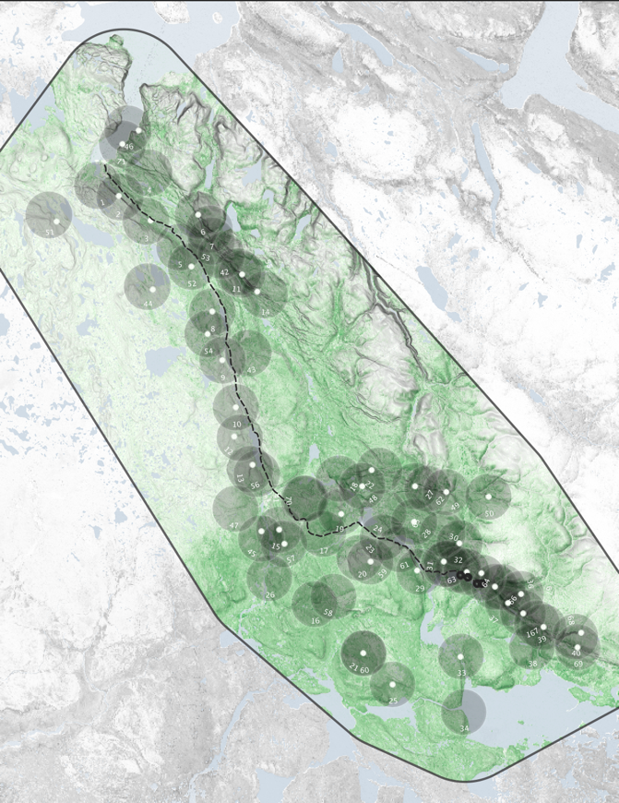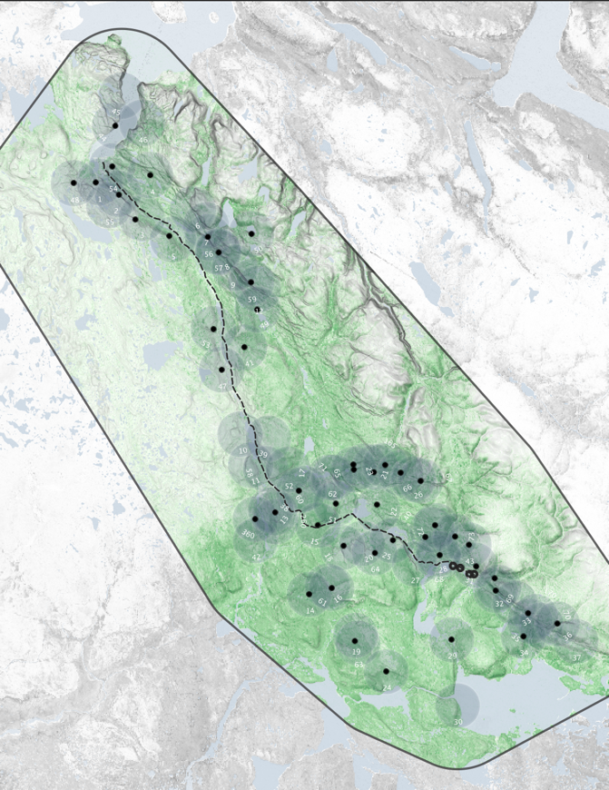

Figure 6‑2 Territories were delineated using cluster analysis with Euclidean proximity and species as the inputs. Although Peregrine Falcon (PEFA) and Rough-legged Hawk (RLHA) territories often overlapped due to similar space use, territories were assigned unique identification numbers depending on the species.

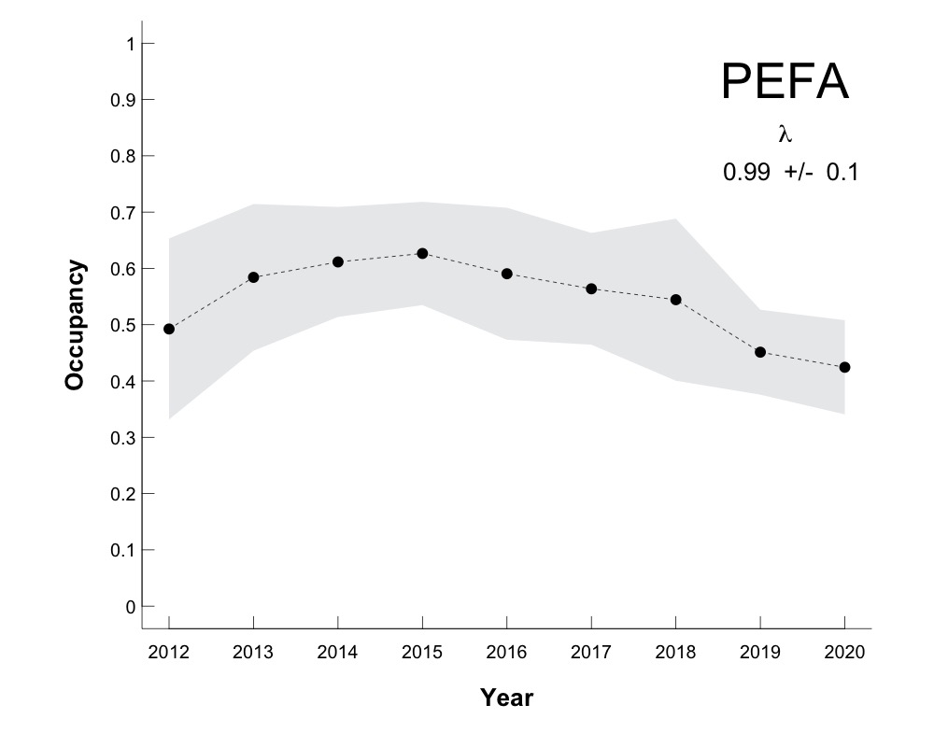

Figure 6‑3 Annual estimates (± 95% confidence intervals) of nesting territory occupancy for Peregrine Falcons within the Raptor Monitoring Area from 2012 – 2019 has remained stable with  = 1.01  0.17.

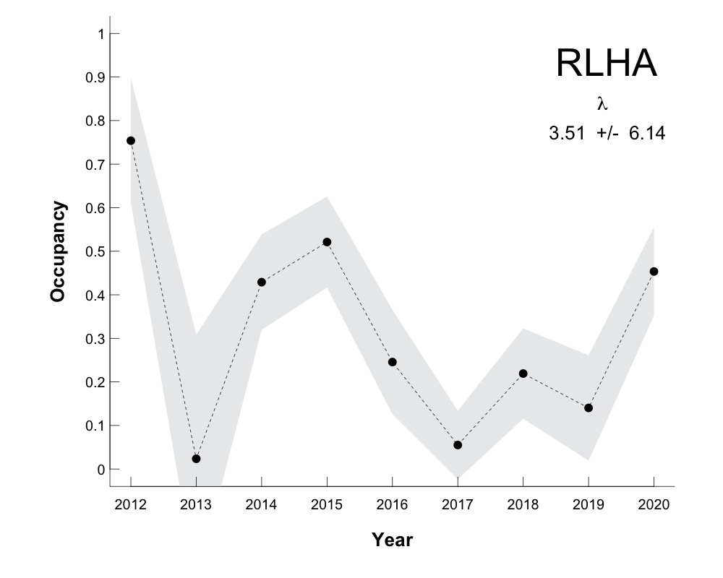

Figure 6‑4 Annual estimates (± 95% confidence intervals) of nesting territory occupancy for Rough-legged Hawks within the Raptor Monitoring Area from 2012 –2019.

Although  is positive, 95% confidence intervals overlap 1.0 indicating that the overall trend is stable.

Table 6‑3 Site occupancy modeling for Peregrine Falcons incorporates the main parameters inherent to metapopulation dynamics (i.e., colonization (γ), and extinction (ε)).

|  |  |  |  |  |  |  |  |
| --- | --- | --- | --- | --- | --- | --- | --- |
| **Model** | **K** | **AICc** | **Delta_AICc** | **ModelLik** | **AICcWt** | **LL** | **Cum.Wt** |
| psi + ε(year) + γ(year) + p(year) | 23 | 1474.15 | 0.00 | 1.00 | 0.88 | -706.19 | 0.88 |
| psi + ε + γ + p(year) | 4 | 1480.64 | 6.49 | 0.04 | 0.03 | -736.09 | 0.92 |
| psi + ε(dnon) + γ + p | 5 | 1481.28 | 7.13 | 0.03 | 0.03 | -735.30 | 0.94 |
| psi + ε + γ(dnon) + p | 5 | 1482.78 | 8.63 | 0.01 | 0.01 | -736.05 | 0.96 |
| psi + ε + γ(dist2dist) + p | 5 | 1482.85 | 8.71 | 0.01 | 0.01 | -736.09 | 0.97 |
| psi + ε(dist2dist) + γ + p | 5 | 1482.87 | 8.72 | 0.01 | 0.01 | -736.09 | 0.98 |
| psi + ε(dnon) + γ(dnon) + p | 6 | 1483.56 | 9.41 | 0.01 | 0.01 | -735.30 | 0.99 |
| psi + ε(dist2dist) + γ(dist2dist) + p | 6 | 1485.13 | 10.98 | 0.00 | 0.00 | -736.08 | 0.99 |
| psi(dist2dist) + ε(year) + γ(year) + p | 17 | 1485.27 | 11.13 | 0.00 | 0.00 | -721.61 | 0.99 |
| psi + ε(dist2dist*dnon) + γ + p | 7 | 1485.80 | 11.65 | 0.00 | 0.00 | -735.25 | 1.00 |
| psi + ε + γ(dist2dist*dnon) + p | 7 | 1486.41 | 12.26 | 0.00 | 0.00 | -735.55 | 1.00 |
| psi(dist2dist) + ε(dist2dist) + γ(dist2dist) + p | 7 | 1487.00 | 12.85 | 0.00 | 0.00 | -735.85 | 1.00 |
| psi + ε(dist2dist*dnon) + γ(dist2dist*dnon) + p | 10 | 1492.06 | 17.91 | 0.00 | 0.00 | -734.70 | 1.00 |
| *Model selection was conducted using Akaike Information Criterion (AIC). Model parameters reflect first-year occupancy, colonization, extinction and detection. Covariates used to model the above parameters were distance to nearest neighbour (dnon), distance to disturbance (dist2dist), and year.* | | | | | | | |

Table 6‑4 Site occupancy modeling for Rough-legged Hawks incorporates the main parameters inherent to metapopulation dynamics (i.e., colonization (γ), and extinction (ε)).

|  |  |  |  |  |  |  |  |
| --- | --- | --- | --- | --- | --- | --- | --- |
| **Model** | **K** | **AICc** | **Delta_AICc** | **ModelLik** | **AICcWt** | **LL** | **Cum.Wt** |
| psi + ε(year) + γ(year) + p(year) | 23 | 825.94 | 0.00 | 1.00 | 1.00 | -381.73 | 1.00 |
| psi(dist2dist) + ε(year) + γ(year) + p | 17 | 854.16 | 28.22 | 0.00 | 0.00 | -405.89 | 1.00 |
| psi + ε + γ + p(year) | 11 | 872.26 | 46.32 | 0.00 | 0.00 | -423.46 | 1.00 |
| psi + ε + γ(dist2dist) + p | 5 | 936.30 | 110.36 | 0.00 | 0.00 | -462.79 | 1.00 |
| psi + ε(dnon) + γ + p | 5 | 936.78 | 110.84 | 0.00 | 0.00 | -463.03 | 1.00 |
| psi + ε + γ(dist2dist*dnon) + p | 7 | 937.59 | 111.65 | 0.00 | 0.00 | -461.12 | 1.00 |
| psi + ε(dnon) + γ(dnon) + p | 6 | 937.64 | 111.70 | 0.00 | 0.00 | -462.32 | 1.00 |
| psi + ε + γ(dnon) + p | 5 | 937.84 | 111.90 | 0.00 | 0.00 | -463.57 | 1.00 |
| psi + ε(dist2dist) + γ(dist2dist) + p | 6 | 938.58 | 112.64 | 0.00 | 0.00 | -462.79 | 1.00 |
| psi(dist2dist) + ε(dist2dist) + γ(dist2dist) + p | 7 | 940.10 | 114.16 | 0.00 | 0.00 | -462.38 | 1.00 |
| psi + ε(dist2dist) + γ + p | 5 | 940.94 | 115.00 | 0.00 | 0.00 | -465.12 | 1.00 |
| psi + ε(dist2dist*dnon) + γ + p | 7 | 941.21 | 115.27 | 0.00 | 0.00 | -462.93 | 1.00 |
| psi + ε(dist2dist*dnon) + γ(dist2dist*dnon) + p | 10 | 941.93 | 115.99 | 0.00 | 0.00 | -459.59 | 1.00 |
| *Model selection was conducted using Akaike Information Criterion (AIC). Model parameters reflect first-year occupancy, colonization, extinction and detection. Covariates used to model the above parameters were distance to nearest neighbour (dnon), distance to disturbance (dist2dist), and year.* | | | | | | | |

#### 5.2.6.4 Reproductive Success

Mean brood size for Peregrine Falcons and Rough-legged Hawks within the RMA in 2019 was 1.53±1.2 and 0.45±1.04 nestlings per fully-surveyed occupied site, respectively (Table 6‑5). These values are within the range calculated for all survey years combined (0.76±1.19 to 2.38±1.60 for Peregrine Falcons, and 0.0 to 2.3±1.24 for Rough-legged Hawks). It should be noted that although productivity was within the range of values calculated annually from 2012 to 2019, the count of nestlings (Total Production) should be evaluated in conjunction with mean brood size. The count of nestlings for Peregrine Falcons and Rough-legged Hawks at fully surveyed nesting territories in 2019 was 66 and 5 nestlings, respectively.

Table 6‑5 Mean brood size for Peregrine Falcons and Rough-legged Hawks within the Raptor Monitoring Area from 2011 – 2019 for fully surveyed sites.

|  | **PEFA** | | | | | | | | **RLHA** | | | | | | | |
| --- | --- | --- | --- | --- | --- | --- | --- | --- | --- | --- | --- | --- | --- | --- | --- | --- |
| **2012** | **2013** | **2014** | **2015** | **2016** | **2017** | **2018** | **2019** | **2012** | **2013** | **2014** | **2015** | **2016** | **2017** | **2018** | **2019** |
| Mean brood size ± SD | 0.76±1.19 | 1.43±1.05 | 1.59±1.44 | 1.98±1.18 | 2.38±1.60 | 1.22±1.61 | 0.94±1.20 | 1.53±1.22 | 1.44±1.14 | 0 | 2.22±0.76 | 2.30±1.24 | 1.78±1.55 | 1.00±1.15 | 0.58±0.90 | 0.45±1.04 |
| Total production | 13 | 33 | 65 | 95 | 114 | 61 | 46 | 66 | 26 | 0 | 60 | 106 | 32 | 5 | 7 | 5 |
| *Mean brood sized is used here as for studies in which mortality that occurs between hatching and the first observation of the brood is unknown, and nestlings are equal to, or greater than 10 days of age, but less than Minimum Acceptable Age for Assessing Success.* | | | | | | | | | | | | | | | | |

Variation in the probability of nest survival among Peregrine Falcons and Rough-legged Hawks was poorly explained by distance to nearest neighbor, distance to disturbance, and an interaction between them (Table 6‑6, Figure 6‑5, Figure 6‑7). In general, model performance was improved by allowing intercepts to randomly vary according to nest sites and years, and further improved by adding a spatial correlation structure. For Rough-legged Hawks, the top model included random intercepts for year and brood. However, the model with a fixed spatial correlation structure had a delta AIC of 0.1; therefore a visualization of the spatial structure was included for reference in Figure 6‑8. For Peregrine Falcons, nest survival was best explained by a spatial correlation structure that remained fixed among all years. Nest survival models for both species benefitted from the inclusion of random spatial correlation, indicating spatial patterns throughout the RMA (Figure 6‑6 and Figure 6‑8). Potential sources of spatial correlation include variation in food availability, environmental conditions, disturbance effects not captured by fixed variables, or various combinations of all three.

Table 6‑6 Model selection results for nest survival of Peregrine Falcons and Rough-legged Hawks within the Raptor Monitoring Area.

|  |  |  |  |  |  |
| --- | --- | --- | --- | --- | --- |
| **RLHA** | | | **PEFA** | | |
| Model | WAIC | Delta | Model | WAIC | Delta |
| fixed + r(b) + r(y) | 190.9 | 0.0 | fixed + r(b) + r(y) + spat | 414.4428 | 0 |
| fixed + r(b) + r(y) + spat | 191.0 | 0.0 | fixed + r(b) + r(y) | 430.0265 | 15.5837 |
| fixed + r(b) + r(y) + spat/time(AR1) | 191.9 | 0.9 | fixed + r(b) + r(y) + spat/time(AR1) | 430.52 | 16.0772 |
| fixed + r(b) + r(y) + spat/time | 192.4 | 1.5 | fixed + r(b) + r(y) + spat/time | 431.4 | 16.9572 |
| fixed | 229.8 | 38.9 | fixed + r(b) | 461.0648 | 46.622 |
| fixed + r(b) | 229.8 | 38.9 | fixed | 461.1276 | 46.6848 |
| *The fixed term in the model description refers to the variables distance to the nearest occupied territory, distance to disturbance, and the interaction between the two. The term r(variable) refers to a random grouping variable, and the “spat” terms refer to three different spatial correlation structures: 1) spat/temp(AR1) references an autoregressive term where spatial correlation is linked to the previous year, 2) spat/temp(year) refers to a correlation structure that changes each year, and 3) spat refers to a spatial correlation structure that remains fixed among all years. Top models are those with the lowest WAIC, and delta refers to the difference between the respective model and the top.* | | | | | |

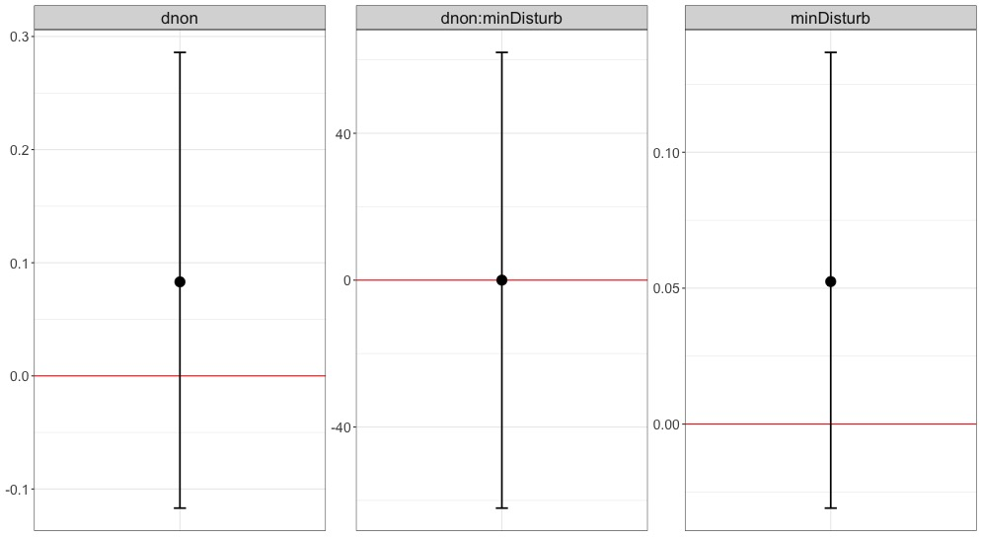

Figure 6‑5 Posterior mean with 95% credible intervals from the top model for Peregrine Falcon nest survival.

As indicated by posterior distributions that overlap zero, distance to nearest occupied neighbour, distance to disturbance, and the interaction of these two covariates all have a weak effect on Peregrine Falcon breeding success. This model also included random variables for brood and year level effects, as well as a spatial correlation structure that remained static from 2012 to 2019.

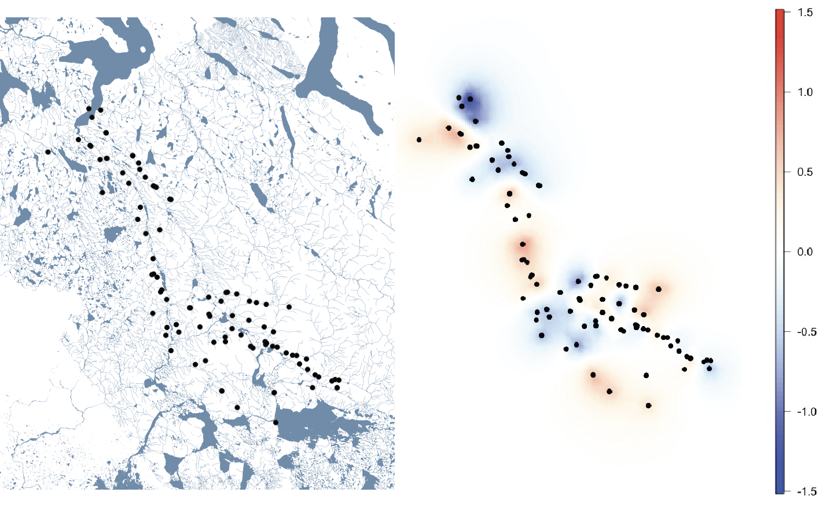

Figure 6‑6 Spatial correlation in probability of nest survival among all nest sites occupied by Peregrine Falcons since 2012.

Multiple spatial structures were compared within the model for peregrine breeding success using WAIC, including spatial correlation that varied by year, autoregressive spatial correlation that depended on the previous year, and spatial correlation that remained static among all years. Static correlation performed the best, and as seen here, there are localized areas where nest survival appears to be consistently above or below the average.

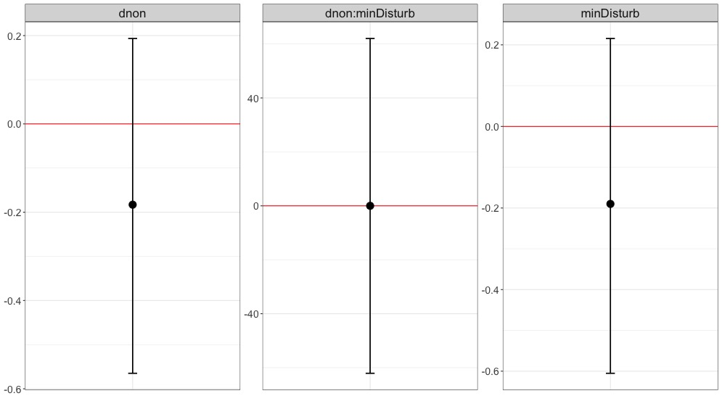

Figure 6‑7 Posterior mean plus 95% credible intervals of fixed covariates contained within the top model for Rough-legged Hawk breeding success.

As indicated by posterior distributions that overlap zero, distance to nearest occupied neighbour, distance to disturbance, and the interaction of these two covariates all have a weak effect on Rough-legged Hawk breeding success. This model also included random variables for brood and year level effects, as well as an auto-regressive spatial/temporal correlation structure from 2012 to 2019.

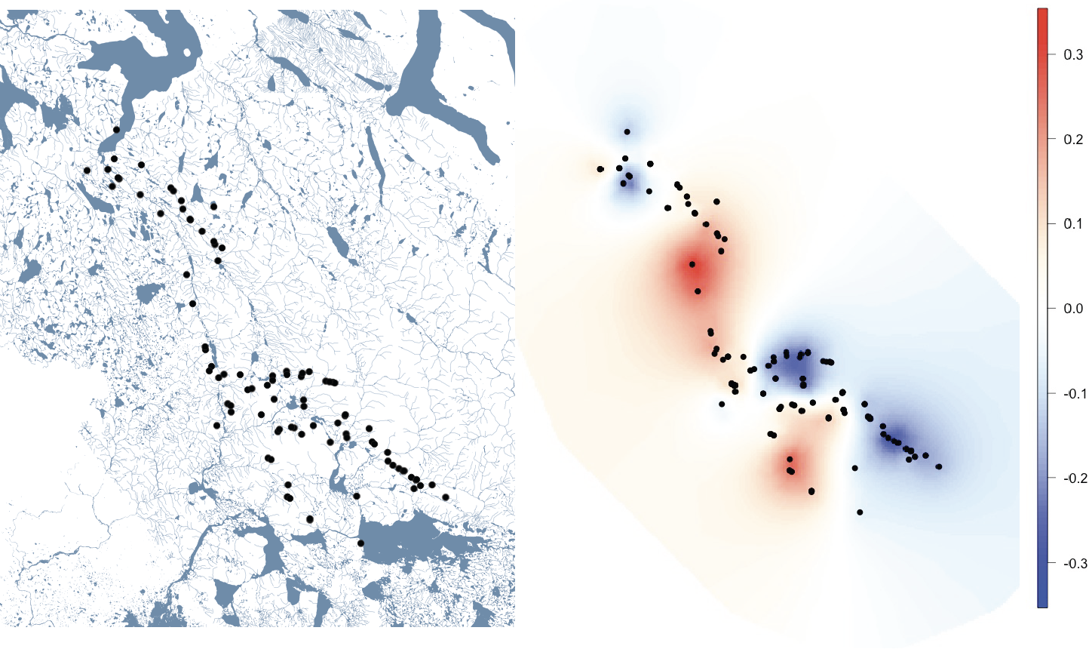

Figure 6‑8 Spatial correlation in nest survival among nest sites occupied by Rough-legged Hawks since 2012.

Three spatial/temporal structures were compared using WAIC. The first structure including spatial correlation that varied by year, the second included autoregressive spatial correlation that depended on the previous year, and the third included spatial correlation that remained the static among all years. For Rough-legged Hawks, nest survival was best explained by a fixed spatial structure that remained static among all years.

#### Small Mammal Monitoring

Small mammal monitoring in 2019 tallied to a total of 2,880 trap-nights over two, 6-night trapping sessions. Over the trapping duration, one collared lemming was captured, 42 traps misfired, and three traps had missing bait. The low detection of small mammals despite high effort indicates a regional low abundance of small mammals in 2019.

#### Avian Prey Monitoring

### Discussion

The raptor section continues to address two main issues raised previously by reviewers: 1) clearly defining terminology; and 2) documenting for the effect of increased detection of alternative nesting sites on occupancy and reproductive success. Although annual variation in reproductive success for Peregrine Falcons and Rough-legged Hawks is apparent, it is most likely representative of natural variability associated with variation in prey availability and weather rather than due to the influence of anthropogenic disturbance. A potential ongoing decline in Peregrine Falcon occupancy and weak evidence that distance to disturbance may be associated with reduced reproductive success, flagged in 2018, does not appear warranted with the additional data collected in 2019. For Rough-legged Hawks, occupancy continues to appear to be cyclical (approximately 4-year oscillation), although the anticipated 2019 upswing in Rough-legged Hawk occupancy and reproductive success was not detected. Small mammal monitoring indicated that lemmings and voles remained at low abundance levels, which strongly suggests that occupancy (and therefore count of nestlings) is associated with the natural small mammal cycle (Gilg et al. 2003).

Monitoring of small mammal abundance was incorporated to address whether occupancy and reproductive success of Rough-legged Hawks cycles with small mammal abundance. In addition, weather-related environmental variables are anticipated to be included with distance to anthropogenic disturbance as part of on-going modelling efforts. Based on the analysis to account for distance to disturbance and distance to nearest neighbour individually, and as an interaction, it appears that there is no negative effect of these factors on occupancy (i.e., estimates ± standard errors of λ overlap with 1.0) or reproductive success.

Future monitoring will continue to focus on multiple nesting territory visits annually. Accounting for detection error is an important component of periodic within-season monitoring (to account for the assumption of closure), and surveys should thus be conducted a minimum of twice per season (early incubation and during brood rearing).

### Inter-Annual Trends

Annual variation in productivity for Peregrine Falcons and Rough-legged Hawks is apparent; however, it is most likely representative of natural variability associated with variation in prey availability and weather rather than due to any influence of anthropogenic disturbance. For Rough-legged Hawks, occupancy appears to be cyclical, and strongly suggests that occupancy is associated with presence of microtine rodents, which are known to cycle approximately every four years. Occupancy of potential nesting sites by Gyrfalcons in the RMA have been too low to monitor annual trends. At the population level, on-going monitoring suggests that distance to disturbance and distance to nearest neighbour (individually and as an interaction) have no negative effect on occupancy or reproductive success for Peregrine Falcons and Rough-legged Hawks.